Class Diagram of namespace **BitSits_Framework**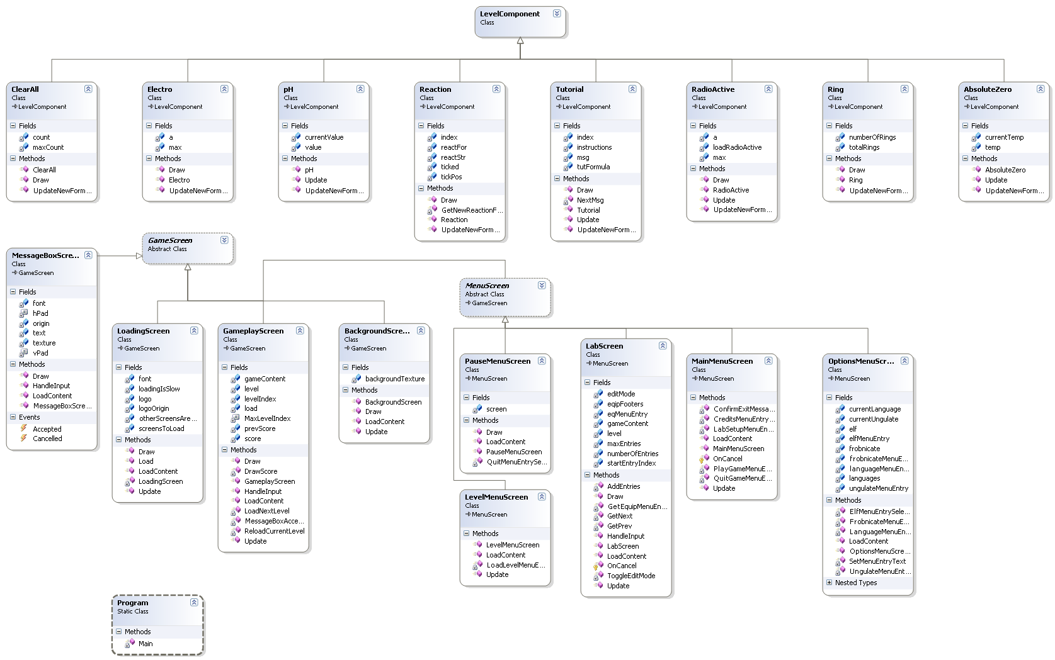

Class Diagram of namespace **BitSits_Framework (cont.)**

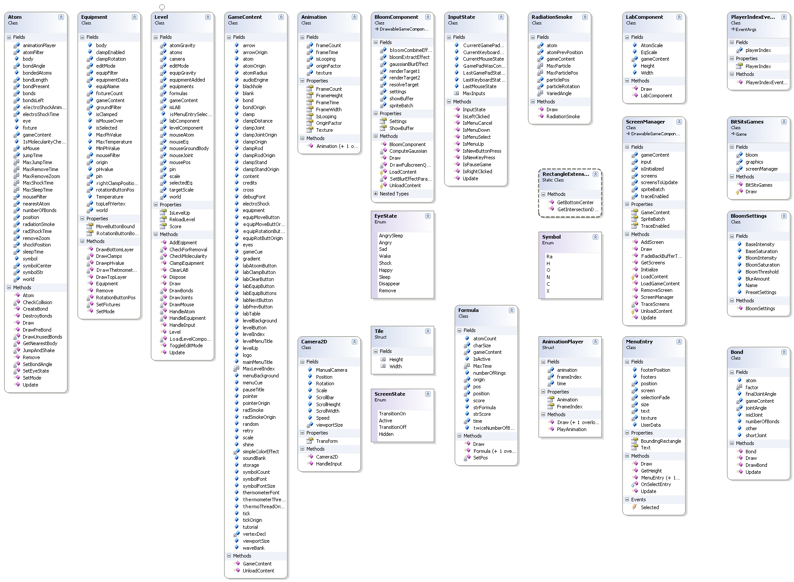

Class Diagram of namespace **GameDataLibrary**

